ACTIVITY-3
Dataset Overview :
The dataset used for this analysis consists of corporate bond ratings, which includes key numerical variables such as CurrentRatio, QuickRatio, and CashRatio This dataset provides synthetic scaled data related to corporate bond ratings.
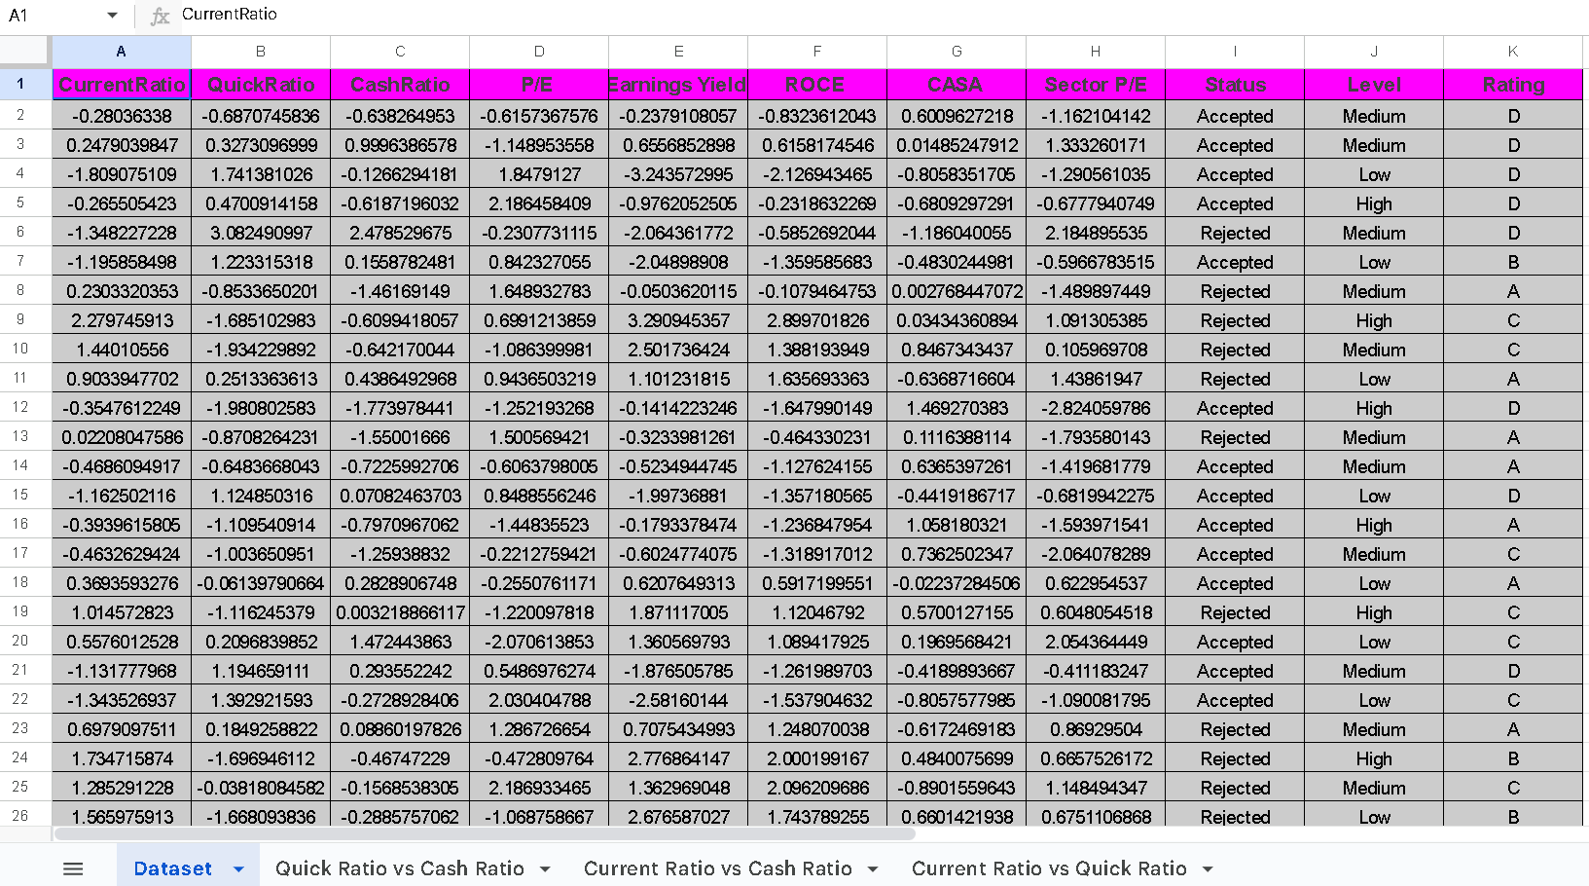
Spreadsheet Link :
https://docs.google.com/spreadsheets/d/1Vdblag7UVTV5S5BJJBQ_knRGle-Gzlnn5oGPvauJK5Y/edit?usp=sharing
SCATTERPLOTS
For this analysis, we examine the relationships between three numerical variables :
CurrentRatio, QuickRatio and Cash Ratio.

Scatter Plot 1 :- Current Ratio vs Quick Ratio
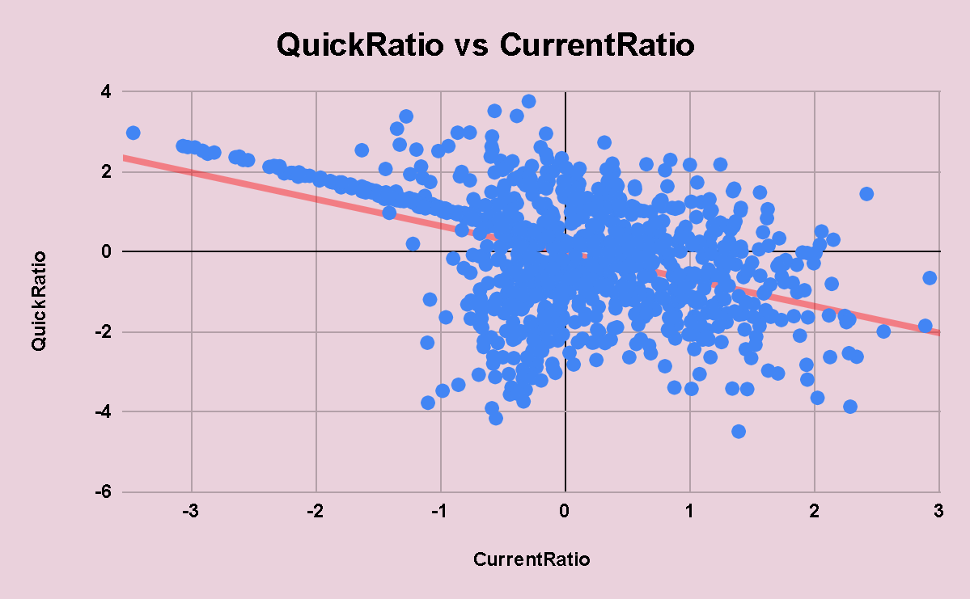
Interpretation: There is a moderate negative relationship between CurrentRatio and QuickRatio. This suggests that companies with higher current ratios tend to have lower quick ratios, and vice versa.

Scatter Plot:- QuickRatio vs CashRatio
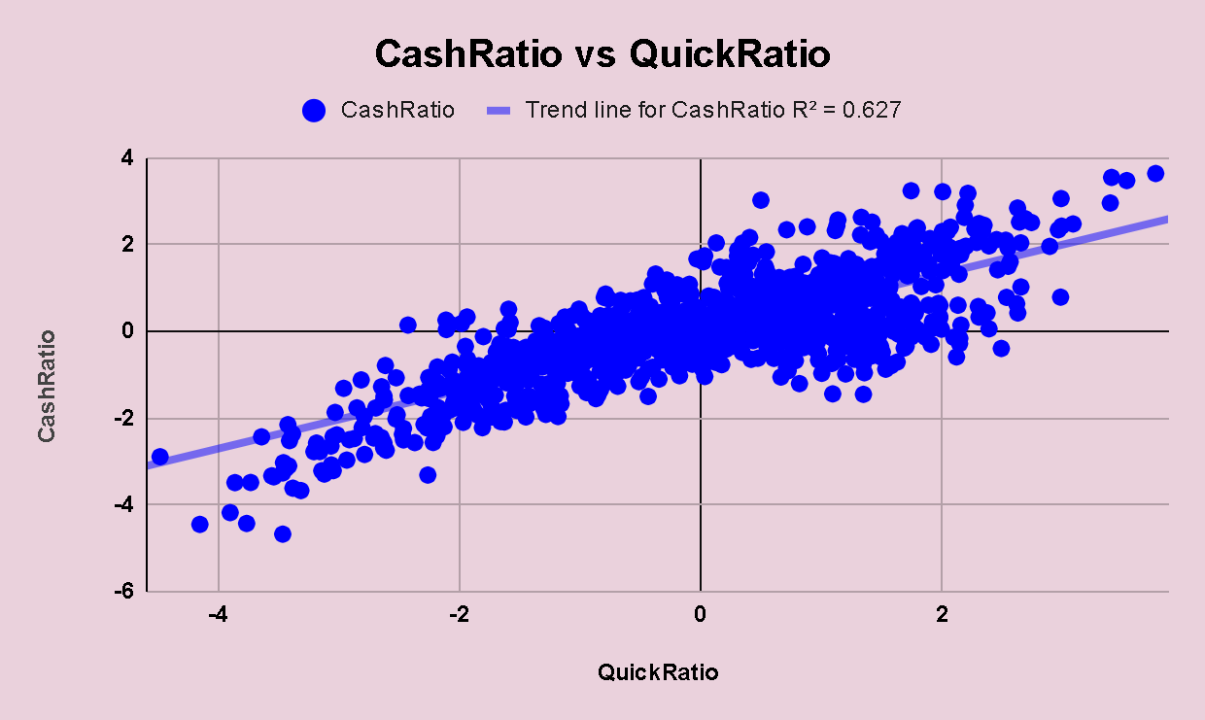
Interpretation: There is a strong positive relationship between Quick Ratio and Cash Ratio. This implies that companies that are liquid in terms of quick assets also maintain higher cash reserves.

Scatter Plot 3:- CurrentRatio vs CashRatio
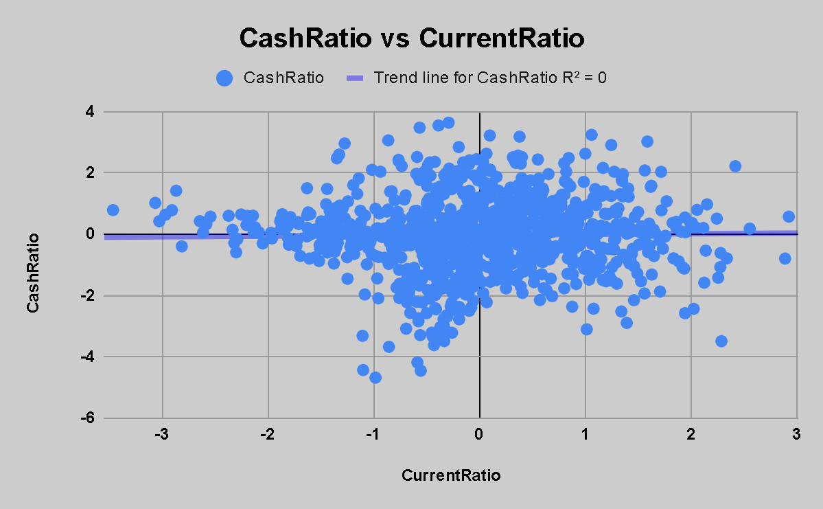
Interpretation: This is a very weak positive relationship, almost negligible. It means that Current Ratio and Cash Ratio are nearly independent and do not vary together significantly.

COVARIANCE CALCULATION
The covariance values between the selected variables are as follows:

- Cov(CurrentRatio, QuickRatio) = -0.6175027303
- Cov(QuickRatio, CashRatio) = 1.404242774
- Cov(CurrentRatio, CashRatio) = 0.01834544703
Interpretation:

- A negative covariance between CurrentRatio and QuickRatio indicates an inverse relationship, where an increase in one variable is associated with a slight decrease in the other.

- A positive covariance between QuickRatio and CashRatio suggests that both variables move together, increasing or decreasing in tandem.

- The near-zero covariance between CurrentRatio and CashRatio indicates almost no linear relationship between these two variables.

MEAN AND STANDARD DEVIATION CALCULATION

The mean and standard deviation for the chosen variables are as follows:

- CurrentRatio:
Mean = -0.002053209181
Standard Deviation = 0.9613188819

Interpretation: The Current Ratio is centered around zero (normalized), and its variability is moderate. This indicates that most values are not far from the average.

- QuickRatio:
Mean -0.01279293548
Standard Deviation = 1.445264062

Interpretation: The Quick Ratio has the highest standard deviation, meaning it shows the most variation among the three ratios. This indicates significant differences in quick asset liquidity across companies.

- CashRatio:
Mean = -0.02123610075
Standard Deviation = 1.226798696

Interpretation: The Cash Ratio also varies considerably, but less than Quick Ratio. It represents moderate variation in cash holdings among companies.

CHEBYSHEV’S INEQUALITY

We use Chebyshev's inequality to estimate the probability that values will lie within a certain range of the mean. For each variable, the upper and lower bounds are calculated for a deviation of 2 standard deviations from the mean:

Chebyshev's inequality provides a lower bound on the probability that a random variable lies within k standard deviations of the mean. The inequality states:

$P(|X-μ| ≥ kσ) ≤ \frac{1}{k^{2}}$

This means that the probability that the value of X lies outside k standard deviations from the mean is at most $\frac{1}{k^{2}}.$The probability that X lies within k standard deviations from the mean is at least 1 - $\frac{1}{k^{2}}.$
We'll use k = 2 which corresponds to 2 standard deviations) for the analysis.

CurrentRatio:
- Mean ($μ$)=-0.0021
- Standard Deviation($σ$)=0.9313

Using k=2:
- Upper Bound = $μ+2σ=$1.9205
- Lower Bound =$μ-2σ=$ -1.9247

Interpretation:At least 75% of the values for CurrentRatio will lie between -1.9247 and
1.9205.

QuickRatio:
- Mean ($μ$)=-0.128
- Standard Deviation($σ$)=1.4453

Using k=2:
- Upper Bound = $μ+2σ=$2.8778
- Lower Bound =$μ-2σ=$ -2.9034

Interpretation:At least 75% of the values for QuickRatio will lie between -2.9034and
2.8778.

CashRatio:
- Mean ($μ$)=-0.0212
- Standard Deviation($σ$)=1.2268

Using k=2:
- Upper Bound = $μ+2σ=$2.4324
- Lower Bound =$μ-2σ=$ -2.4748

Interpretation:At least 75% of the values for CashRatio will lie between -2.4748 and
2.4324 .

